EDA(Exploratory
Data Analysis)

WEEK - 5

REPORT

SUBMITTED BY:

- SAHANAA SREE
E25DA045
WEEK - 5

TOPIC: HEALTH CARE_DATASET.CSV

Problem Statement :
To analyze healthcare data using Power BI by cleaning and transforming the dataset, creating patient and admission dimension tables, grouping patients based on age, establishing relationships between tables, and developing an interactive healthcare dashboard.

Objective :
- To clean and organize healthcare data using Power Query.

- To create Dim_Patient, Dim_Admission, and Fact_Billing tables.

- To create Age Groups using conditional columns.
- To establish relationships between the tables.

- To create an interactive dashboard showing patient and billing information.

Tasks and Deliverables :

- Import the healthcare dataset into Power BI

- Clean and transform the data using Power Query.

- Create age groups: 0–18, 19–35, 36–60, Above 60

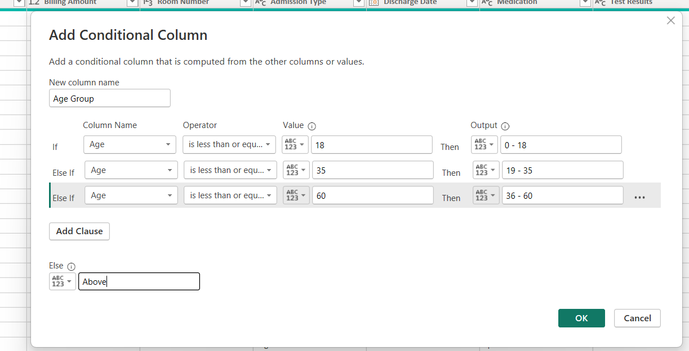

- Create Dim_Patient and Dim_Admission tables.

- Create the Fact_Billing table.

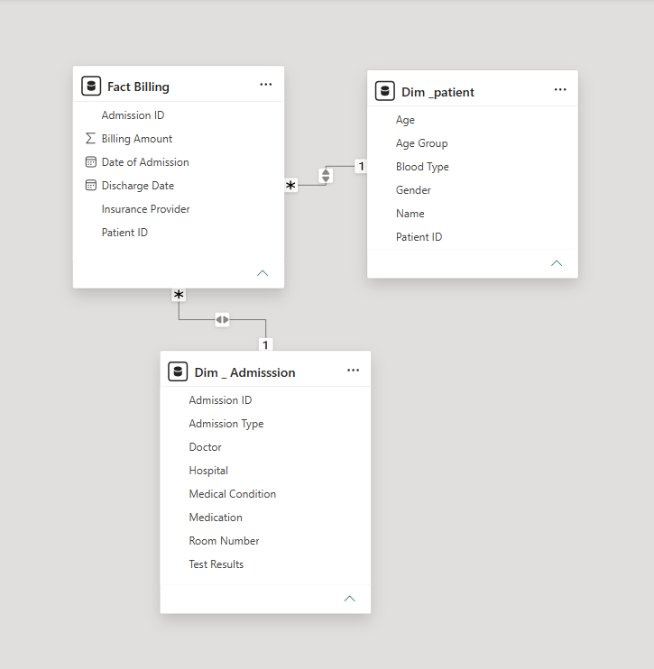

6 . Merge required tables and expand the necessary columns.

7 . Establish relationships between the fact and dimension tables.

8 . Create measures such as Total Patients, Total Billing Amount, and Average Billing Amount.

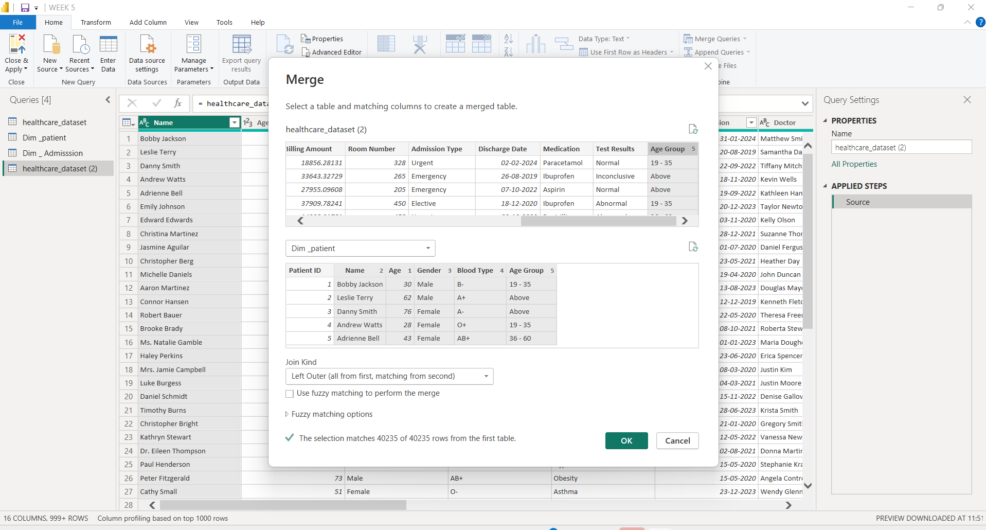

- Design an interactive dashboard with charts, cards, slicers, and filters.

- Analyze patients by age group, medical condition, admission type, insurance provider, and billing amount.

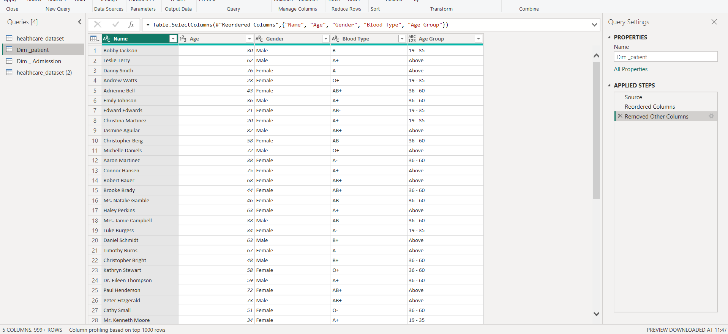

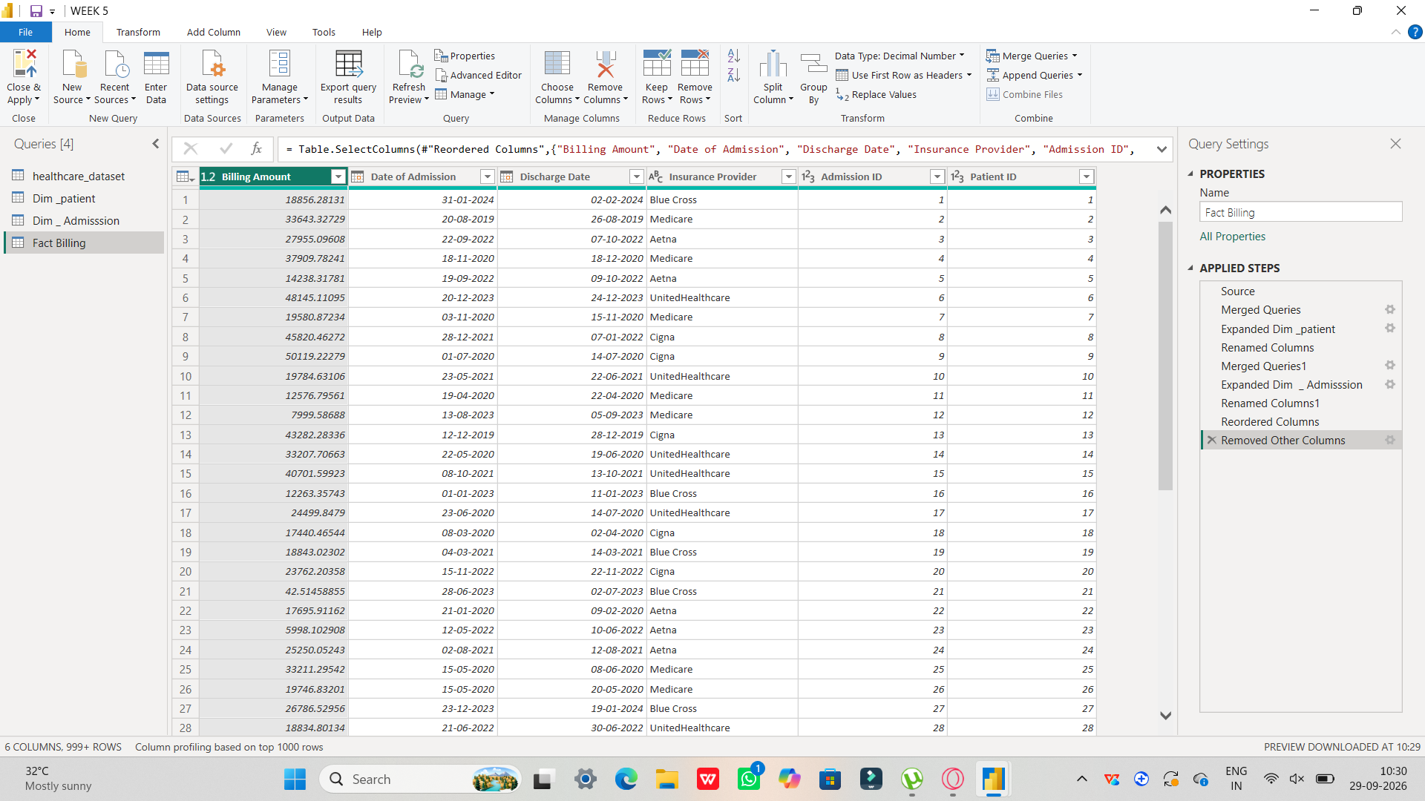

Conclusion :
The healthcare dataset was successfully transformed and modeled in Power BI. The Fact and Dimension tables were connected using appropriate relationships, and an interactive dashboard was created to provide useful insights into patient details, medical conditions, admissions, and billing amounts.

